**DFD DIAGRAM**

DFD graphically representing the functions, or processes, which capture, manipulate, store, and distribute data between a system and its environment and between components of a system. The visual representation makes it a good communication tool between User and System designer. Structure of DFD allows starting from a broad overview and expands it to a hierarchy of detailed diagrams. A process receives input data and produces output with a different content or form. Processes can be as simple as collecting input data and saving in the database, or it can be complex as producing a report containing monthly sales of all retail stores in the northwest region.

**DFD LEVEL 1:**

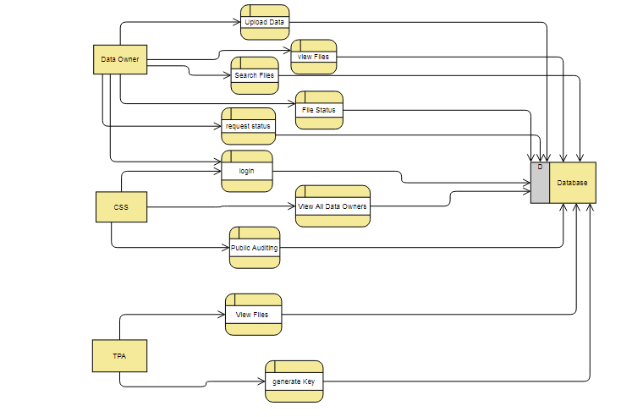

**DFD LEVEL 2:**

